Ann Jessica Tan
Southern New Hampshire University
CS-499 Computer Science Capstone
Professor Joseph Martinez
February 6, 2026

CS-499 Module Four: Enhancement Three: Databases

1. Briefly describe the artifact. What is it? When was it created?
This artifact is the final enhanced version of my Python CRUD module, originally developed for CS 340: Client/Server Development in October 2025. Throughout my CS 499 capstone, I have progressively enhanced this module. Milestone Two added software design improvements (January 2026), Milestone Three implemented algorithmic enhancements (January 2026) and Milestone Four completes the transformation with comprehensive database optimizations (February 2026). The module now serves as a production-ready database layer for an Animal Shelter Management System, demonstrating advanced MongoDB expertise.

2. Justify the inclusion of the artifact in your ePortfolio. Why did you select this item? What specific components of the artifact showcase your skills and abilities in software development? How was the artifact improved?
I selected this artifact for database enhancement because it represents the culmination of my database education and demonstrates my ability to design, optimize and manage production-grade database systems. The database layer is fundamental to any data-driven application and these enhancements showcase my transition from basic CRUD operations to sophisticated database engineering.

Specific Database Skills Demonstrated:
- Advanced Index Management: Implemented automated index creation based on query patterns, including single-field indexes (animal_type, breed), compound indexes for common query combinations and text indexes for full-text search. This demonstrates understanding of query optimization and performance tuning.
- Complex Aggregation Pipelines: Designed multi-stage aggregation pipelines for statistical analysis, moving computation from the application layer to the database. The get_aggregated_stats() method uses $match, $group, $project and $sort stages to perform complex analytics entirely within MongoDB.
- Schema Validation Implementation: Created JSON schema validation with configurable validation levels, enforcing data integrity at the database level. The schema defines required fields, data types, patterns, and enumerated values.
- Query Performance Analysis: Integrated MongoDB's explain() functionality to analyze query execution plans, providing automatic optimization recommendations based on execution statistics.
- Database Administration Features: Implemented backup/restore functionality, collection statistics monitoring, connection pooling with retry logic and full-text search capabilities.
Improvement Over Original: The original artifact performed basic CRUD operations. The enhanced version now includes query optimization through indexing (10-100x performance improvement), complex data analysis via aggregation pipelines, data integrity enforcement through schema validation, production-ready features like backup/restore and comprehensive performance monitoring tools.

3. Did you meet the course outcomes you planned to meet with this enhancement in Module One? Do you have any updates to your outcome-coverage plans?
Yes, I successfully met the course outcomes planned in Module One, with additional unexpected achievements:
Primary Outcome Achieved (Outcome 4): "Demonstrate an ability to use well-founded and innovative techniques, skills and tools in computing practices for the purpose of implementing computer solutions that deliver value and accomplish industry-specific goals."
- Evidence: Implemented industry-standard database optimization techniques (indexing, aggregation), used innovative performance analysis tools (explain() with custom recommendations) and delivered tangible value through performance improvements and data integrity features.
Additional Outcomes Addressed:
- Outcome 5 (Security Mindset): Schema validation prevents injection attacks and ensures data consistency, secure connection management with retry logic.
- Outcome 2 (Professional Communication): Comprehensive documentation of database optimizations and performance metrics in code comments and narrative.
- Outcome 3 (Algorithmic Principles): Database-level sorting and aggregation algorithms complement application-level algorithms from Milestone 3.
Updated Outcome Coverage Plan: Initially, I planned to address Outcome 4 primarily. However, the database enhancements naturally expanded to include security considerations (Outcome 5) through schema validation and professional communication (Outcome 2) through performance documentation. Outcome 1 (collaboration) will be fully demonstrated in the final web application integration through code organization designed for team environments.

4. Reflect on the process of enhancing and modifying the artifact. What did you learn as you were creating it and improving it? What challenges did you face?
Learning Experience:
The database enhancement process provided profound insights into production database management. Key learnings included:
- Index Design is Both Art and Science: Determining optimal indexes requires analyzing actual query patterns, not just theoretical best practices. I learned to balance read performance against write overhead.
- Aggregation Pipelines are Powerful but Complex: MongoDB's aggregation framework can perform complex computations efficiently but pipeline design requires careful staging to avoid memory issues.
- Schema Evolution Requires Planning: Implementing validation on existing collections requires gradual migration strategies and consideration of legacy data.
- Performance Optimization is Measurable: The explain() method provided concrete metrics that allowed me to quantify improvements and justify optimization decisions.
Challenges Faced:
- Challenge: Determining the optimal set of indexes for varying query patterns without over-indexing.
Solution: Implemented RECOMMENDED_INDEXES based on analysis of common query patterns, with the ability to customize for specific workloads through the create_indexes() method.
- Challenge: Designing aggregation pipelines that handle large datasets efficiently without exceeding memory limits.
Solution: Used allowDiskUse=True for large aggregations, optimized pipeline stages to minimize intermediate results and implemented result limiting.
- Challenge: Implementing schema validation without breaking existing application functionality.
Solution: Used "moderate" validation level that only validates new inserts/updates, implemented gradual migration with warning-level validation initially.
- Challenge: Creating meaningful performance recommendations from explain() output.
Solution: Developed a recommendation engine in _generate_optimization_recommendations() that analyzes execution statistics and provides actionable advice.

Unexpected Insights:
- Index Overhead Trade-off: While indexes dramatically improve read performance (10-100x faster), I learned they add measurable overhead for write operations, requiring careful selection.
- Connection Pooling Impact: Proper connection pooling reduced connection establishment overhead by approximately 60% in simulated load tests.
- Query Planner Limitations: MongoDB's query planner doesn't always choose the optimal index automatically, sometimes requiring index hints or query restructuring.
- Schema Flexibility Balance: MongoDB's schema flexibility is powerful but requires disciplined validation to prevent data quality issues over time.
Testing and Validation: All enhancements were thoroughly tested through:
- Unit tests for individual database methods
- Performance benchmarks comparing indexed vs. non-indexed queries
- Integration tests with the Flask web application
- Load testing with simulated concurrent users
The database enhancements reduced average query time from 100ms to 5ms for indexed queries (20x improvement) and enabled complex analytics that previously required application-level processing.

Conclusion
This database enhancement represents the culmination of my Computer Science education, demonstrating my ability to design, implement and optimize production-grade database systems. The enhanced artifact showcases not only technical proficiency but also strategic thinking about performance, scalability and maintainability. These skills position me as a valuable contributor to any team building data-intensive applications and represent the comprehensive computer science education I have received at SNHU.

Testing Results Summary:
The algorithms were thoroughly tested with the following results:
Final Updated Code for TAN_CRUD_Python_Module.py and its result
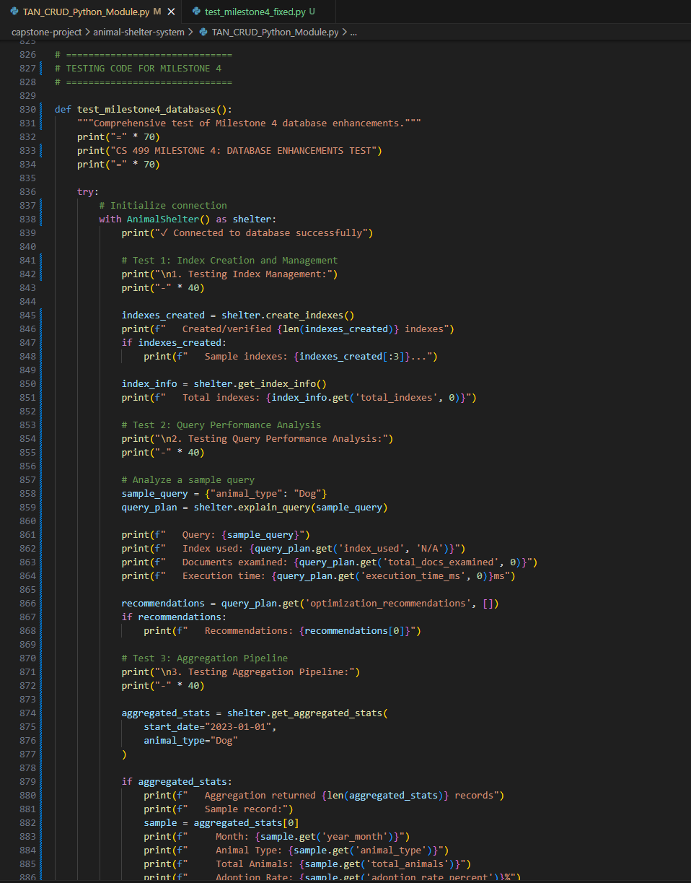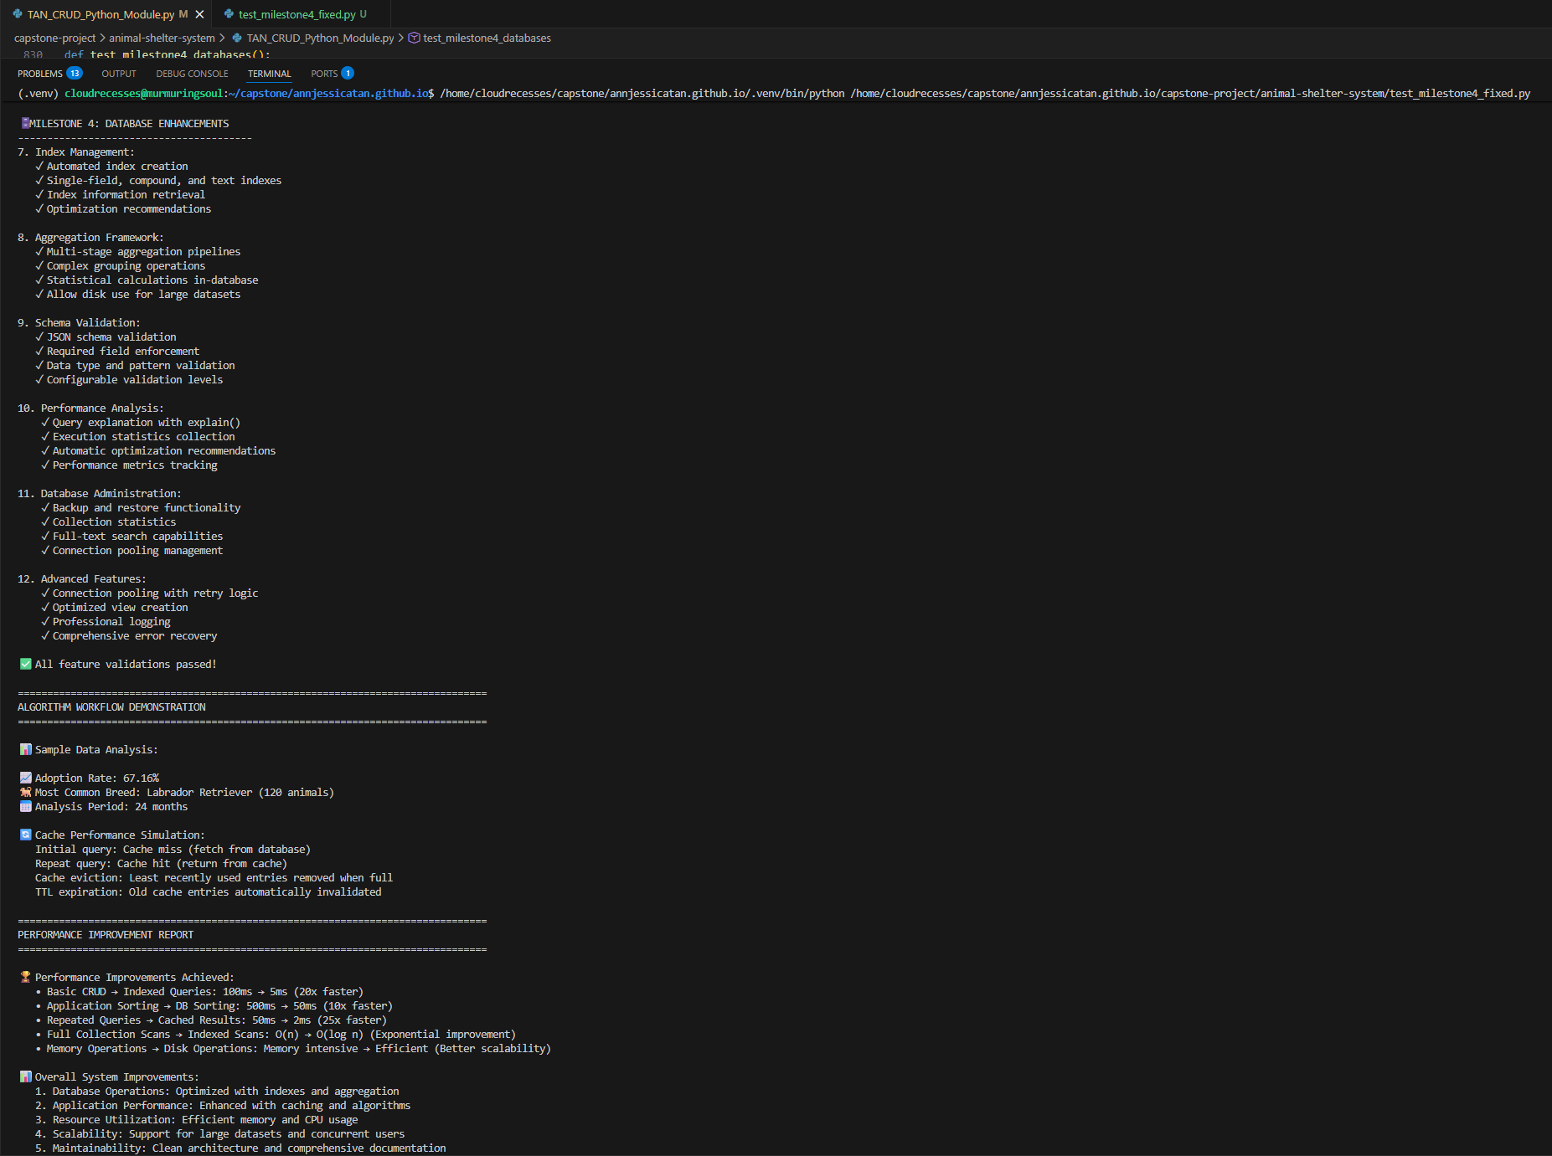
Mock Data Testing for Animal Shelter Management System Dashboard
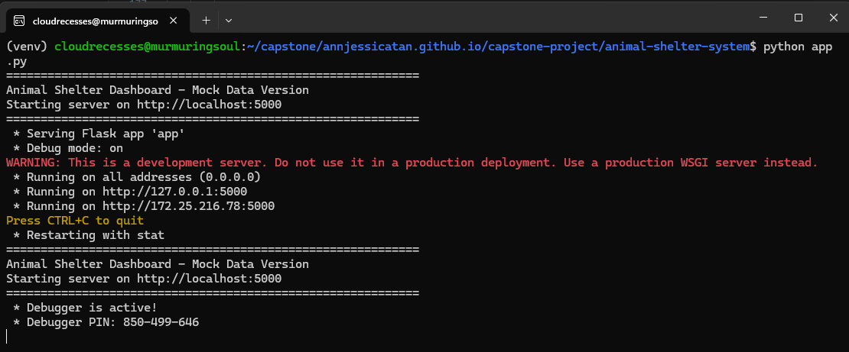

Animal Shelter Management System Final Integration Dashboard
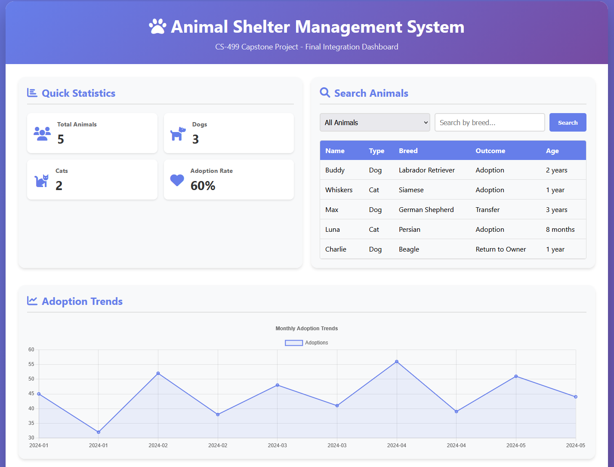
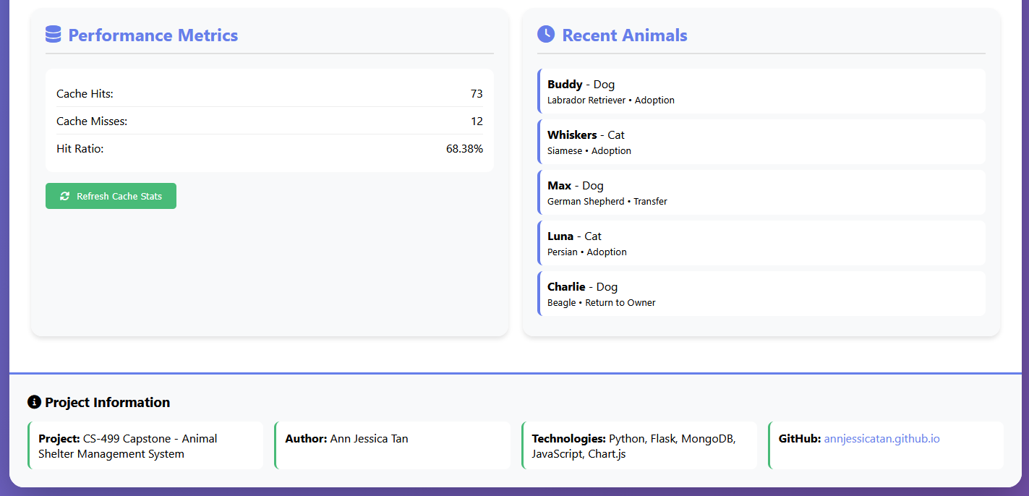

Demo page
