Ann Jessica Tan
Southern New Hampshire University
CS-499 Capstone
Professor Joseph Martinez
January 10, 2026

CS 499 Module One Assignment Template

- Self-Introduction: Address all of the following questions to introduce yourself.

  - How long have you been in the Computer Science program?
I have been in the Computer Science program for approximately 2 years. This is my second bachelor's degree, with my first being in Physical Therapy.

  - What have you learned while in the program? List three of the most important concepts or skills you have learned.

Throughout the program, I have gained a foundational and applied understanding of three critical areas. First, I learned the principles of object-oriented programming and software development, which provide the blueprint for building structured, maintainable, and scalable applications. Second, I developed practical skills in data structures, algorithms, and database management, enabling me to organize, process, and retrieve data efficiently to solve complex problems. Third, I gained experience in the full software development lifecycle (SDLC), including requirements analysis, system design, implementation, testing, and security considerations, which is essential for delivering professional-quality software.

  - Discuss the specific skills you aim to demonstrate through your enhancements to reach each of the course outcomes.

Through my planned enhancements, I aim to demonstrate the following specific skills mapped to the course outcomes:

• Collaborative Development & Communication (Outcome 1 & 2): Conducting a structured code review and producing clear, audience-adapted technical documentation and narratives.
• Algorithmic & Software Design (Outcome 3): Designing and implementing efficient data retrieval algorithms with dynamic filtering, sorting, and pagination, while evaluating design trade-offs.
• Industry-Standard Implementation (Outcome 4): Using well-founded techniques (OOP, Flask, PyMongo) and tools to build a complete, full-stack web application that delivers tangible value as a data management dashboard.
• Security-First Mindset (Outcome 5): Proactively mitigating vulnerabilities through input validation, secure credential management, and defensive error handling in both the database layer and web interface.

  - How do the specific skills you will demonstrate align with your career plans related to your degree?

My career goal is to become either a Software Developer or a Data Analyst. The skills demonstrated in this project directly align with both paths. For a Software Developer role, building a full-stack Flask application showcases my proficiency in backend logic, database integration, and frontend presentation which are core competencies for the position. For a Data Analyst role, the project highlights my ability to interface with databases, implement search and filter algorithms, and present data through an interactive dashboard, proving I can build tools to extract and visualize insights. This project serves as a concrete, portfolio-ready example of my ability to deliver end-to-end technical solutions.

  - How does this contribute to the specialization you are targeting for your career?

This project contributes significantly to my targeted specialization by allowing me to pivot from academic exercises to a integrated, industry-relevant application. It demonstrates not just isolated skills in Python or databases, but the synthesis of those skills into a single, cohesive product. Whether I specialize in software development or data analytics, this project proves I can understand a problem domain, design an appropriate system architecture, and execute the implementation using modern tools and best practices. It moves my portfolio from a collection of assignments to a showcase of professional competency.

- ePortfolio Set Up:

  - Submit a screen capture of your ePortfolio GitHub Pages home page that clearly shows your URL.
    - You already have a repository in GitHub where you uploaded projects in previous courses. Your ePortfolio will reside in GitHub but can link to work at other sites, such as Bitbucket.

  - Use the GitHub Pages link in the Resource section for directions on:
    - How to create your GitHub website and publish code to GitHub Pages
    - Issues, such as adding links to other sites

  - Paste a screenshot of your GitHub Pages home page with your URL clearly showing in the space below.

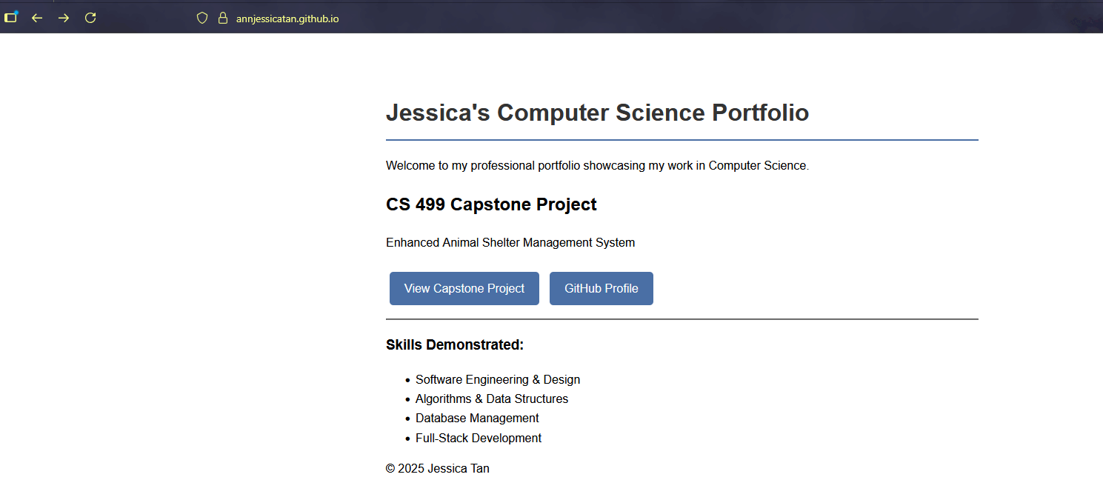

- Enhancement Plan:

I will use a single artifact, my CS 340 CRUD module 4, and enhance it across all three categories, culminating in a complete Flask web application. This unified approach demonstrates progressive skill development on a cohesive project.

  - Category One: Software Engineering and Design
    - Select an artifact that is aligned with the software engineering and design category and explain its origin. Submit a file containing the code for the artifact you choose with your enhancement plan.

The artifact I have selected is the CRUD.py module from my CS 340: Client/Server Development course. This artifact originated as a project milestone where I developed a Python class to provide Create and Read functionality for a MongoDB database containing animal shelter data. It represents my initial foray into connecting application logic to a database using an object-oriented approach.

Note: Your artifact may be work from the following courses:

- IT 145: Foundation in Application Development
- CS 250: Software Development Lifecycle
- CS 260: Data Structures and Algorithms
- IT 315: Object Oriented Analysis and Design
- CS 320: Software Testing, Automation, and Quality Assurance
- CS 330: Computational Graphics and Visualization
- CS 340: Advanced Programming Concepts
- CS 350: Emerging Systems Architectures and Technologies
- CS 360: Mobile Architecture and Programming
- IT 365: Operating Environments
- IT 380: Cybersecurity and Information Assurance
- CS 405: Secure Coding
- CS 410: Reverse Software engineering
- IT 340: Network and Telecommunication Management
- IT 380: Cybersecurity and Information Assurance

    - Describe a practical, well-illustrated plan for enhancement in alignment with the category, including a pseudocode or flowchart that illustrates the planned enhancement.

My enhancement plan focuses on completing and professionally refining this module. First, I will complete the CRUD functionality by implementing the missing update and delete methods. Second, I will improve the software design by refactoring the code: extracting hard-coded database credentials into a separate configuration file for security and maintainability, adding comprehensive error handling and input validation, and enhancing code documentation and structure following PEP 8 guidelines. This transforms the module from a partial classroom exercise into a robust, reusable software component.

Pseudocode for the Enhanced update method:

FUNCTION update(self, query, new_data)
IF query is NOT a dictionary OR new_data is NOT a dictionary THEN
RAISE exception for invalid input
TRY
result = collection.update_one(query, {'$set': new_data})
IF result.modified_count > 0 THEN
RETURN True (success)
ELSE
RETURN False (no document matched)
CATCH any database exception
LOG the error
RETURN False (operation failed)

    - Explain how the planned enhancement will demonstrate specific skills and align with course outcomes.

      - Identify and describe the specific skills you will demonstrate that align with the course outcome.

I will demonstrate software design and engineering skills by applying object-oriented design principles to create a cohesive, self-contained module. This includes skills in code refactoring for clarity and maintainability, security-aware development by removing sensitive data from source code, and defensive programming through robust error handling. Specifically for security, I will demonstrate secure credential management by removing hard-coded passwords and implementing input validation to prevent NoSQL injection attacks, key aspects of developing a security mindset.

      - Select one or more of the course outcomes below that your enhancement will align with.

This enhancement primarily aligns with Course Outcome 5: "Develop a security mindset that anticipates adversarial exploits in software architecture and designs to expose potential vulnerabilities, mitigate design flaws, and ensure privacy and enhanced security of data and resources." It demonstrates this through secure credential management and input validation. It also supports Outcome 4 through the use of industry-standard refactoring techniques and Outcome 3 through the logical design of the update/delete operations.

Course Outcomes:

- Employ strategies for building collaborative environments that enable diverse audiences to support organizational decision-making in the field of computer science.
- Design, develop, and deliver professional-quality oral, written, and visual communications that are coherent, technically sound, and appropriately adapted to specific audiences and contexts.
- Design and evaluate computing solutions that solve a given problem using algorithmic principles and computer science practices and standards appropriate to its solution while managing the trade-offs involved in design choices.
- Demonstrate an ability to use well-founded and innovative techniques, skills, and tools in computing practices for the purpose of implementing computer solutions that deliver value and accomplish industry-specific goals.
- Develop a security mindset that anticipates adversarial exploits in software architecture and designs to expose potential vulnerabilities, mitigate design flaws, and ensure privacy and enhanced security of data and resources.

  - Category Two: Algorithms and Data Structures

- Select an artifact that is aligned with the algorithms and data structures category and explain its origin. Submit a file containing the code for the artifact you choose with your enhancement plan. You may choose work from the courses listed under Category One.

For this category, I will enhance the same CS 340 CRUD Module 4 artifact (attached as TAN_CRUD_Python_Module.py with this submission). While its original purpose was database connectivity, its read method provides a foundation upon which I can layer advanced algorithmic features for querying and processing the dataset. I have also included the original test script TAN_ModuleFourTestScript.ipynb to demonstrate the initial functionality.

- Describe a practical, well-illustrated plan for enhancement in alignment with the category, including a pseudocode or flowchart that illustrates the planned enhancement.

I will enhance the module by adding sophisticated data querying and analysis features to the read functionality. This includes:

1. Implementing an advanced search method that accepts multiple, optional filter criteria (such as animal type, breed, age range, date range) and constructs a dynamic MongoDB query.
2. Adding server-side sorting capability, allowing results to be ordered by any field (such as name, intake date).
3. Implementing data aggregation to calculate key shelter statistics, such as adoption rates by animal type or monthly intake counts.

Pseudocode for the Enhanced search_with_filters method:

FUNCTION search_with_filters(self, filters_dict, sort_field, sort_order)
INITIALIZE an empty query dictionary
FOR EACH key, value IN filters_dict
IF value is not empty THEN
ADD key:value to query dictionary
TRY
cursor = collection.find(query)
IF sort_field is provided THEN
cursor.sort(sort_field, sort_order)
RETURN list(cursor)
CATCH any exception
LOG error
RETURN empty list

- Explain how the planned enhancement will demonstrate specific skills and align with course outcomes.

  - Identify and describe the specific skills you will demonstrate to align with the course outcome.

I will demonstrate algorithmic thinking and data structure manipulation by designing logic to dynamically build complex database queries from user input. This involves skills in problem decomposition (breaking down a multi-filter search into discrete steps), efficiency consideration (ensuring queries are structured to use database indexes effectively), and data analysis (using aggregation to derive meaningful statistics from raw records).

  - Select one or more of the course outcomes listed under Category One that your enhancement will align with.

This enhancement strongly aligns with Course Outcome 3: "Design and evaluate computing solutions that solve a given problem using algorithmic principles and computer science practices and standards appropriate to its solution, while managing the trade-offs involved in design choices." It also supports Outcome 4 by using the PyMongo driver's advanced features to implement a valuable data exploration tool.

  - Category Three: Databases

    - Select an artifact that is aligned with the databases category and explain its origin. Submit a file containing the code for the artifact you choose with your enhancement plan. You may choose work from the courses listed under Category One.

Again, I will use the CS 340 CRUD Module 4 (TAN_CRUD_Python_Module.py) artifact as the core database component. Its origin is directly in database interaction, making it the ideal foundation for this category. For the database component, I will source publicly available animal shelter data or create a representative sample dataset to populate a fresh MongoDB instance, demonstrating full system setup from database creation to application deployment.

    - Describe a practical, well-illustrated plan for enhancement in alignment with the category, including a pseudocode or flowchart that illustrates the planned enhancement.

My plan is to build a functional web application interface for the database using the Flask framework. This will create a tangible "client" for the "server" (database) logic I've already built. The enhancement involves:

1) Creating a Flask application (app.py) that imports my enhanced CRUD module.
2) Designing a series of HTML templates (using Bootstrap for styling) to provide pages for browsing, searching, adding, and editing animal records.
3) Writing Flask route functions that call my CRUD methods and render the results in the templates. This demonstrates a complete client-server architecture. This enhancement builds directly upon the completed module from Category One and the algorithmic features from Category Two, showing how separate enhancements integrate into a final product.

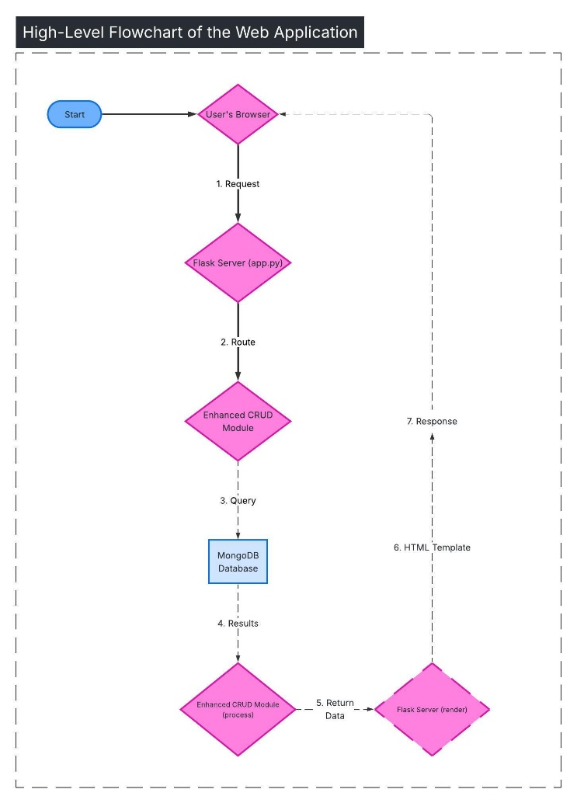

    - Explain how the planned enhancement will demonstrate specific skills and align with course outcomes.

      - Identify and describe the specific skills you will demonstrate that align with the course outcome.

I will demonstrate full-stack database application development skills. This encompasses backend web development with Flask, frontend templating with HTML/Jinja2, and the crucial integration layer that connects a user interface to a database system. It shows I can take a backend module and productize it into an accessible application, a key skill for both software developers and data analysts who need to share their work.

      - Select one or more of the course outcomes listed under Category One that your enhancement will align with.

This enhancement aligns with Course Outcome 4: "Demonstrate an ability to use well-founded and innovative techniques, skills, and tools in computing practices for the purpose of implementing computer solutions that deliver value and accomplish industry-specific goals." It also supports Outcome 2 (professional communications) by creating an adapted, visual interface for a technical system, and touches on Outcome 1, as the web interface serves as a collaboration tool for diverse users.

- ePortfolio Overall Skill Set

  - Accurately describe the skill set to be illustrated by the ePortfolio overall.
    - Skills and outcomes planned to be illustrated in the code review

The code review video will illustrate my ability to analyze and communicate technical plans (Outcome 2). I will walk through the existing codebase, critically evaluate its structure and limitations, and articulate a clear, justified plan for enhancement. This demonstrates collaborative and reflective practices (Outcome 1) by simulating a peer or team review environment.

    - Skills and outcomes planned to be illustrated in the narratives

The written narratives for each artifact will demonstrate my capacity for professional, reflective communication (Outcome 2). I will explain not just what I changed, but why, justifying design choices, discussing challenges overcome, and mapping my work to course outcomes and industry best practices. This shows metacognitive skill and the ability to present technical work to varied audiences.

    - Skills and outcomes planned to be illustrated in the professional self-assessment

The professional self-assessment will serve as a holistic showcase of my integrative learning and career readiness. It will tie together my journey through the CS program, the strategic choices made in this capstone, and my future professional goals. It will demonstrate my ability to synthesize technical skills (Outcomes 3, 4, 5) with professional competencies like communication (Outcome 2) and collaboration (Outcome 1) to present myself as a qualified candidate in the field of computer science.

